**Part-1**

**Create Jenkins server environment in AWS using Terraform**

Commands used:

Terraform init

Terraform plan

Terraform apply

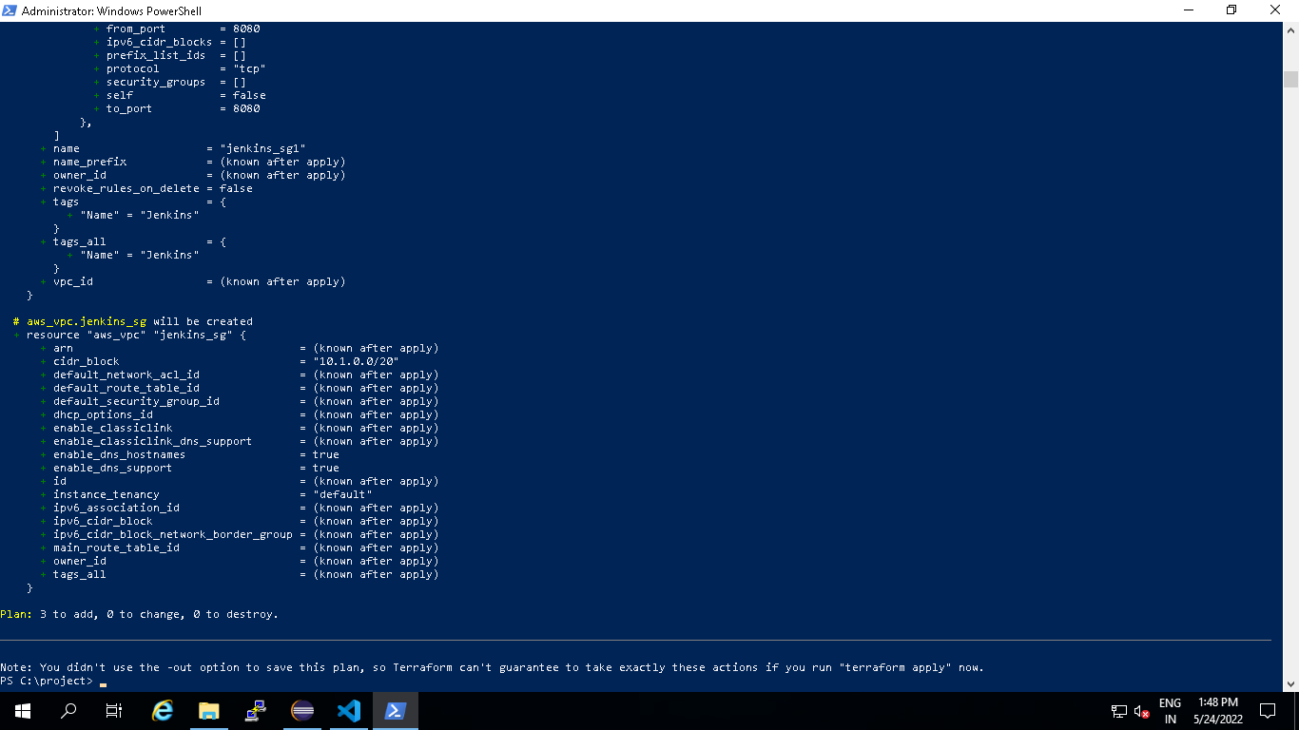

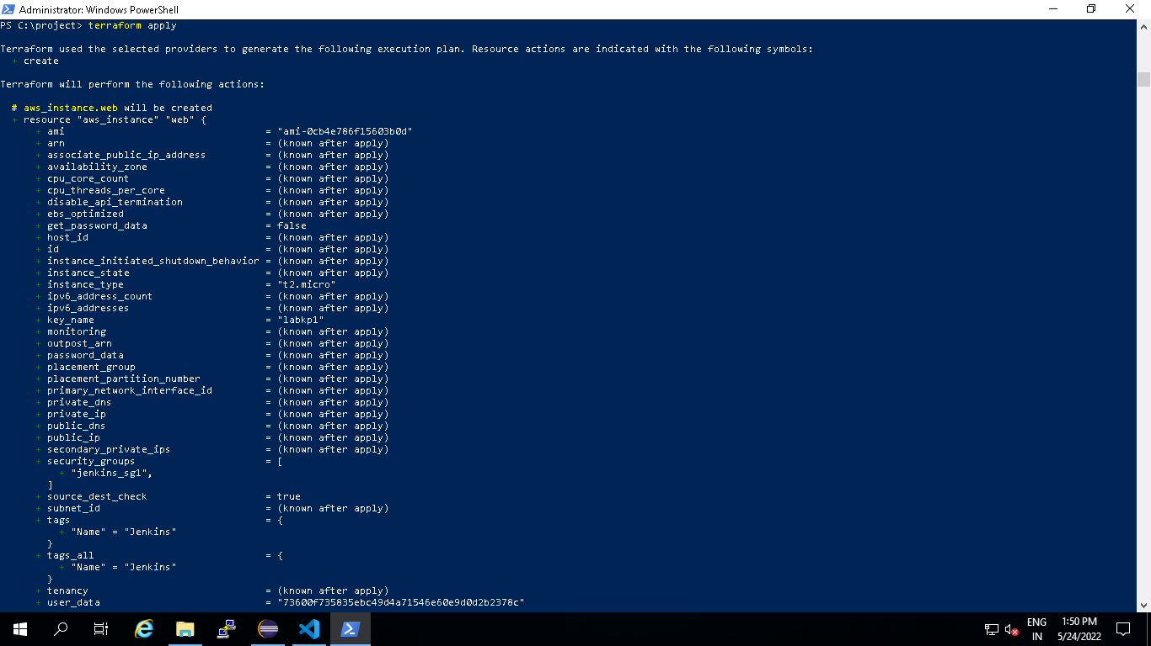

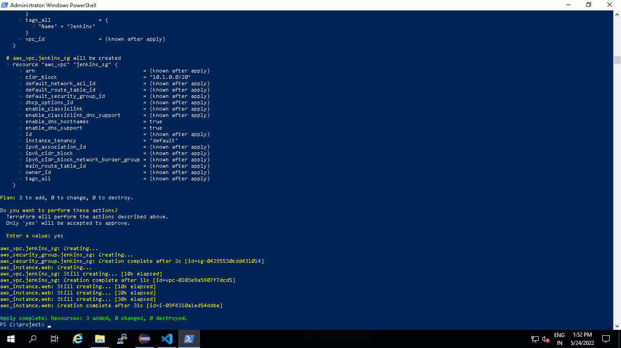

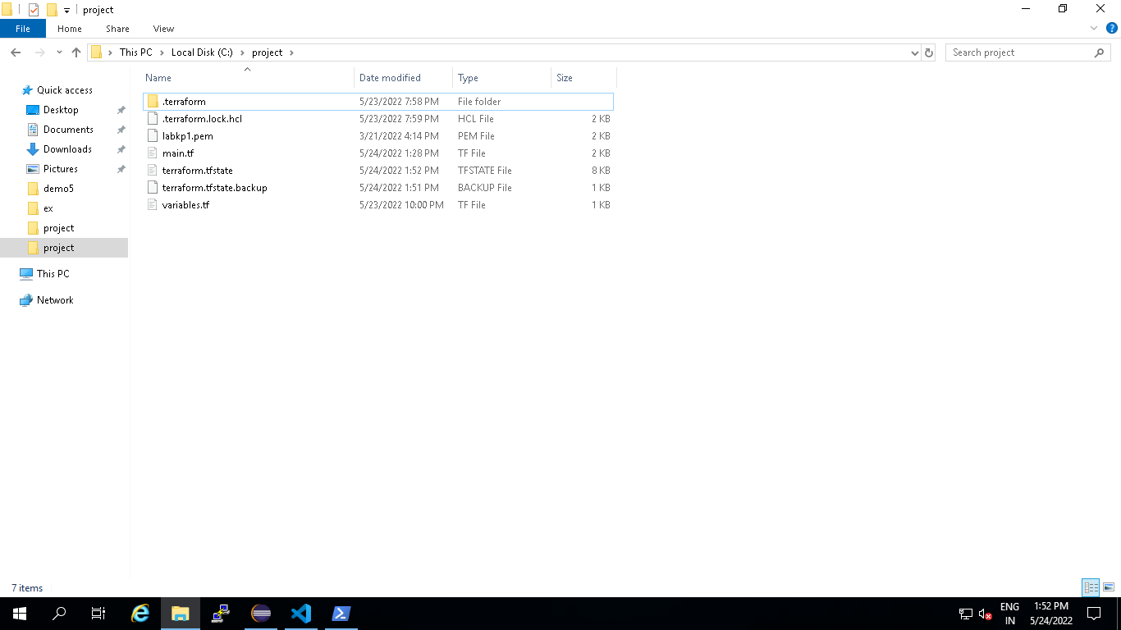

**Part-2: Phase 1**

**Create Maven Project with Archtype as web application in eclipse**

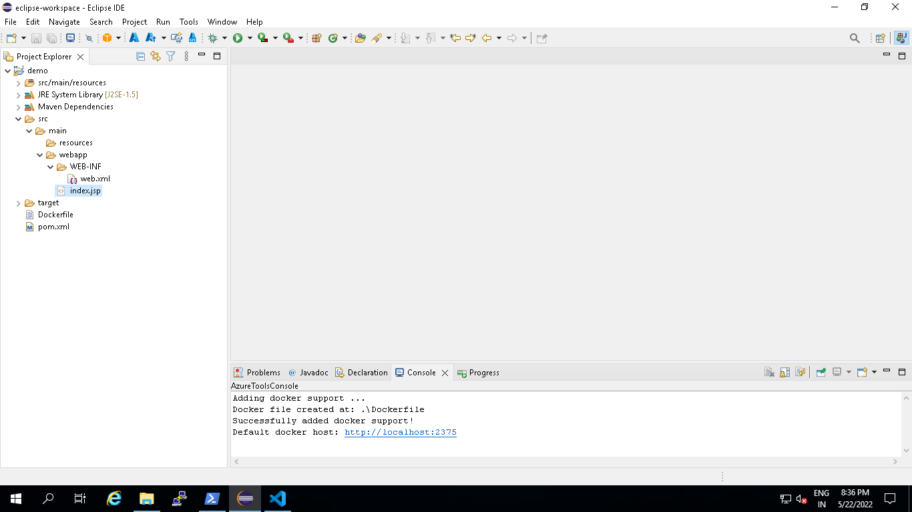

Modify index.jsp under src/main/webcontent

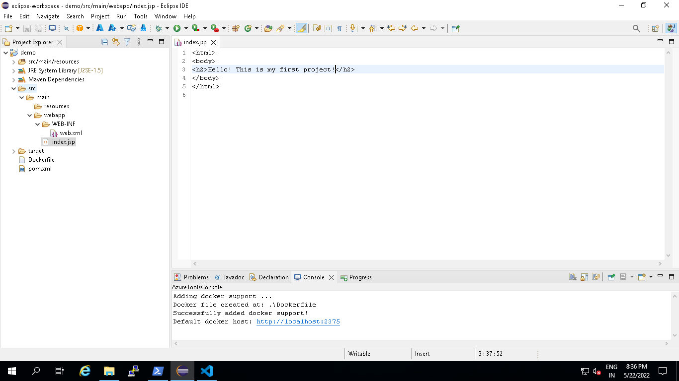

**Part 2-Phase2:**

**Generate docker file under project folder of your app and Modify FORM statement to use tomcat as base image**

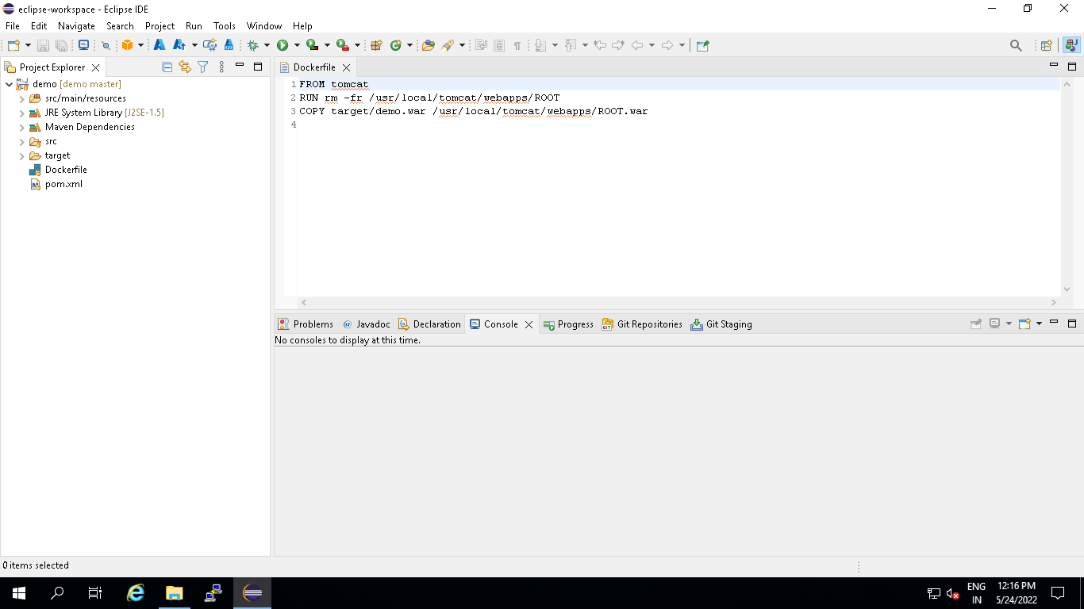

**Part 2-Phase 3**

**Create a git hub repository and copy the repo URL**

https://github.com/Bakya1/CI-CD-Project.git

In Eclipse convert the app in to a local repo from Team menu share Project Option

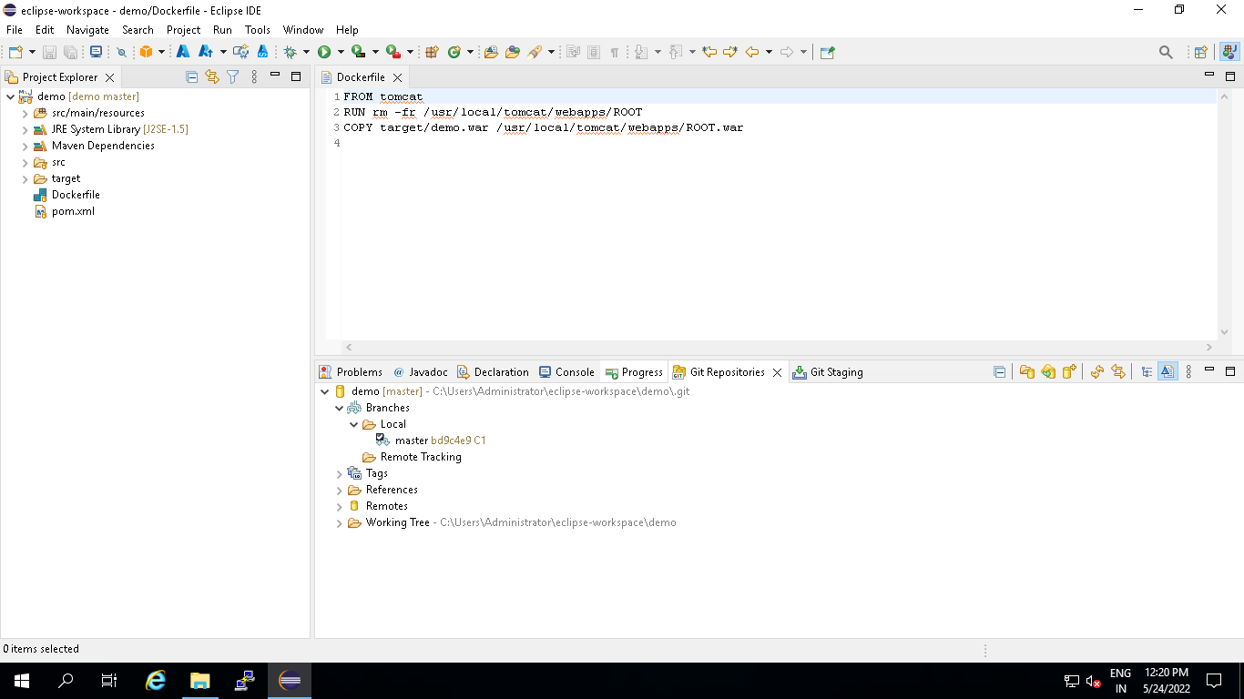

Commit and Push the code to remote repo

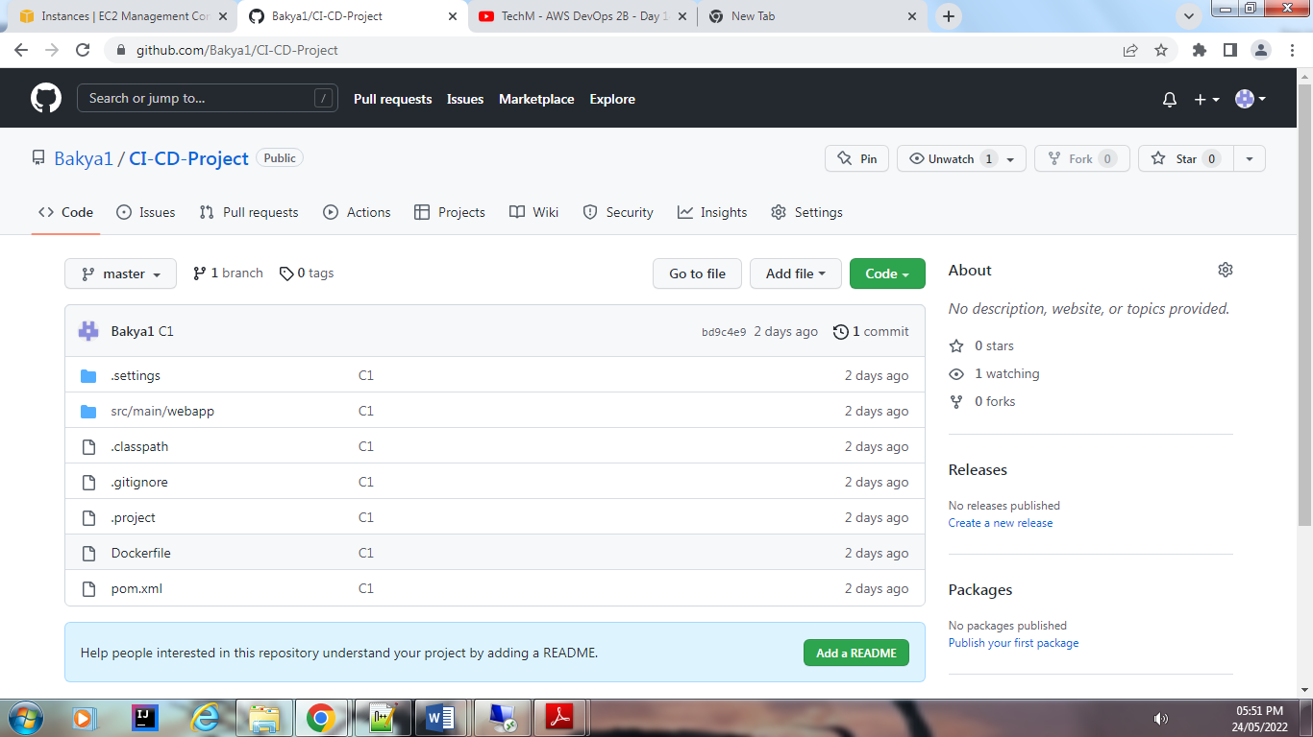

**Part2-Phase 4**

**Modify Project index.jsp, Commit and Push to remote repo**

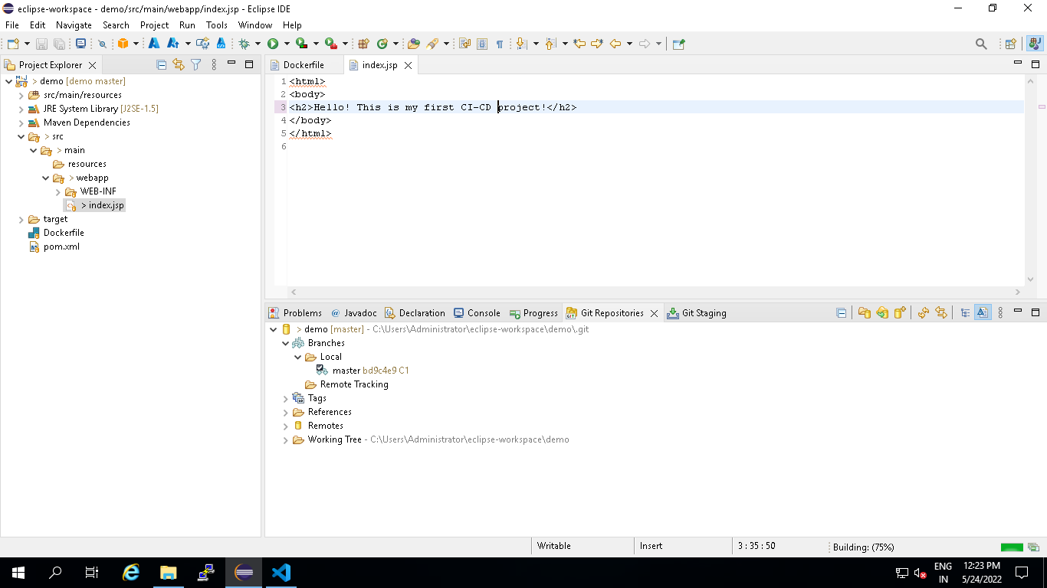

**Check for the change in remote Repo**

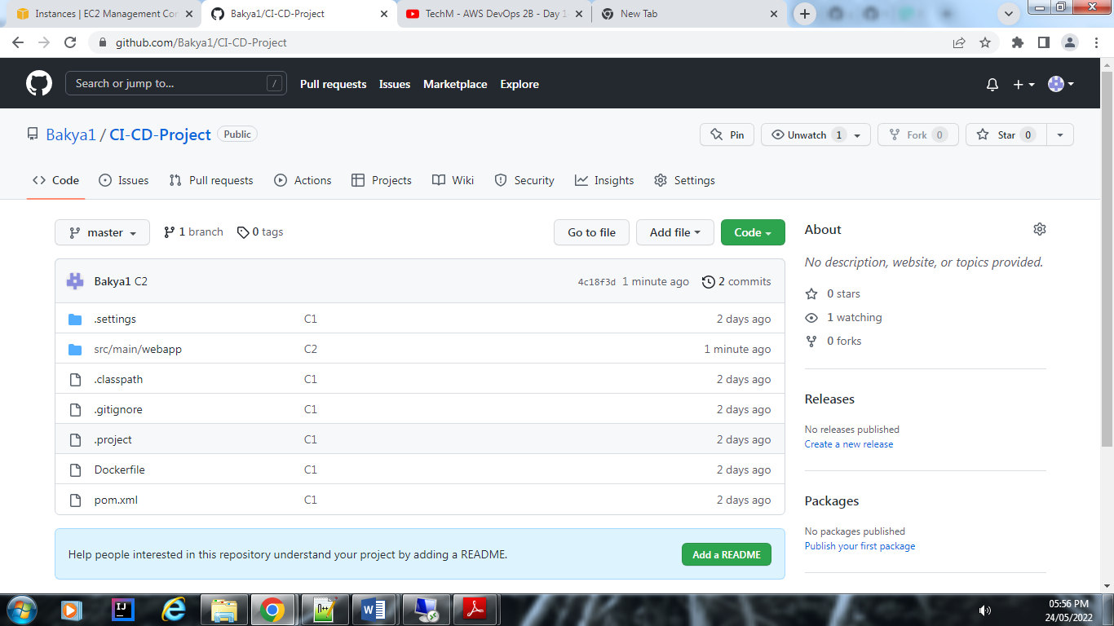

**Part 2-Phase 5**

Jenkins configuration

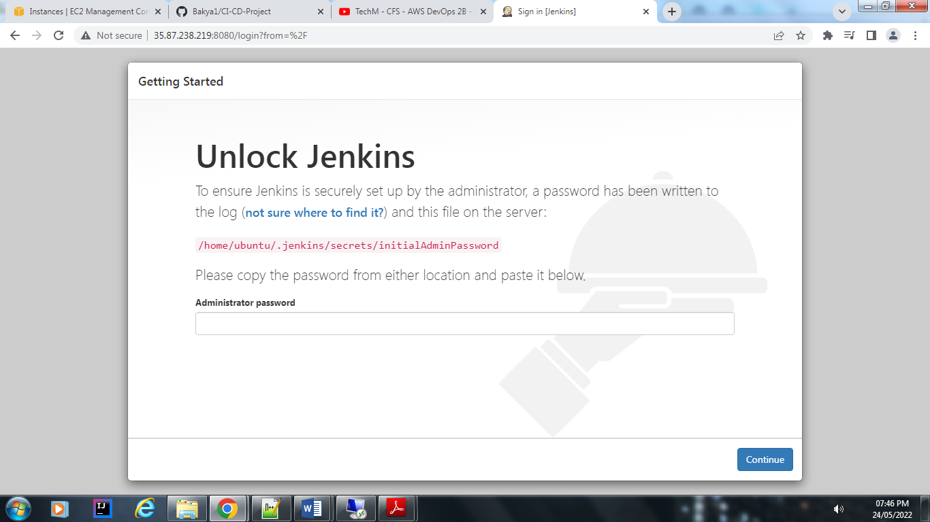

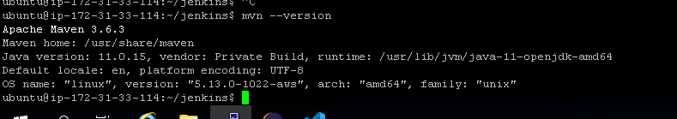

Jenkins pipeline:

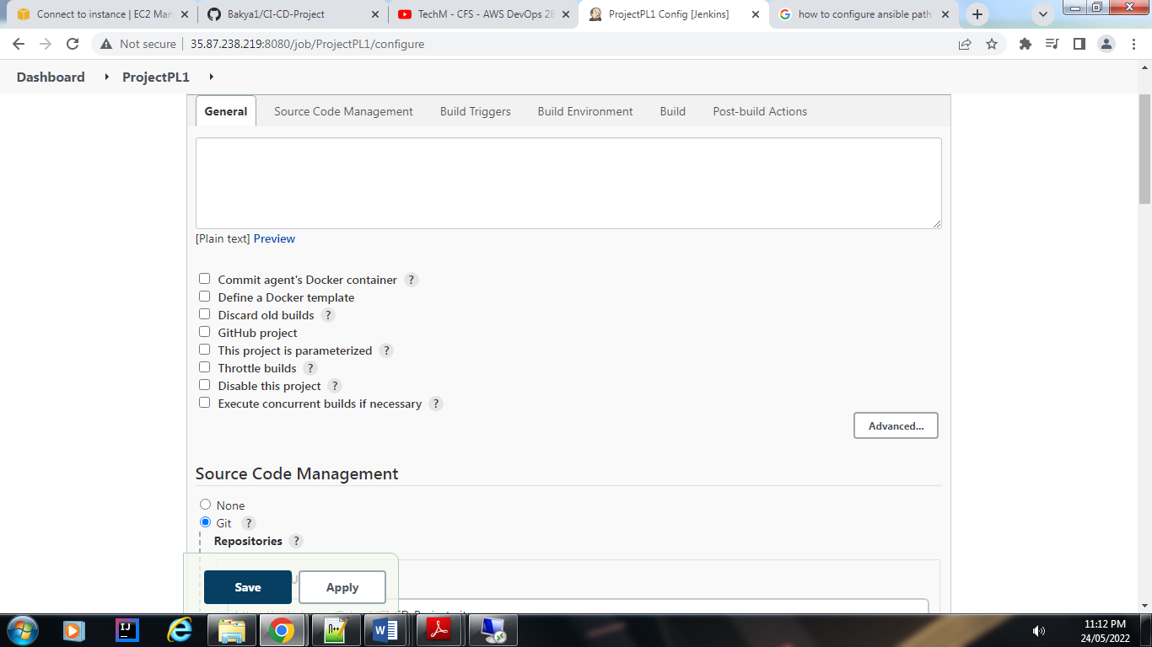

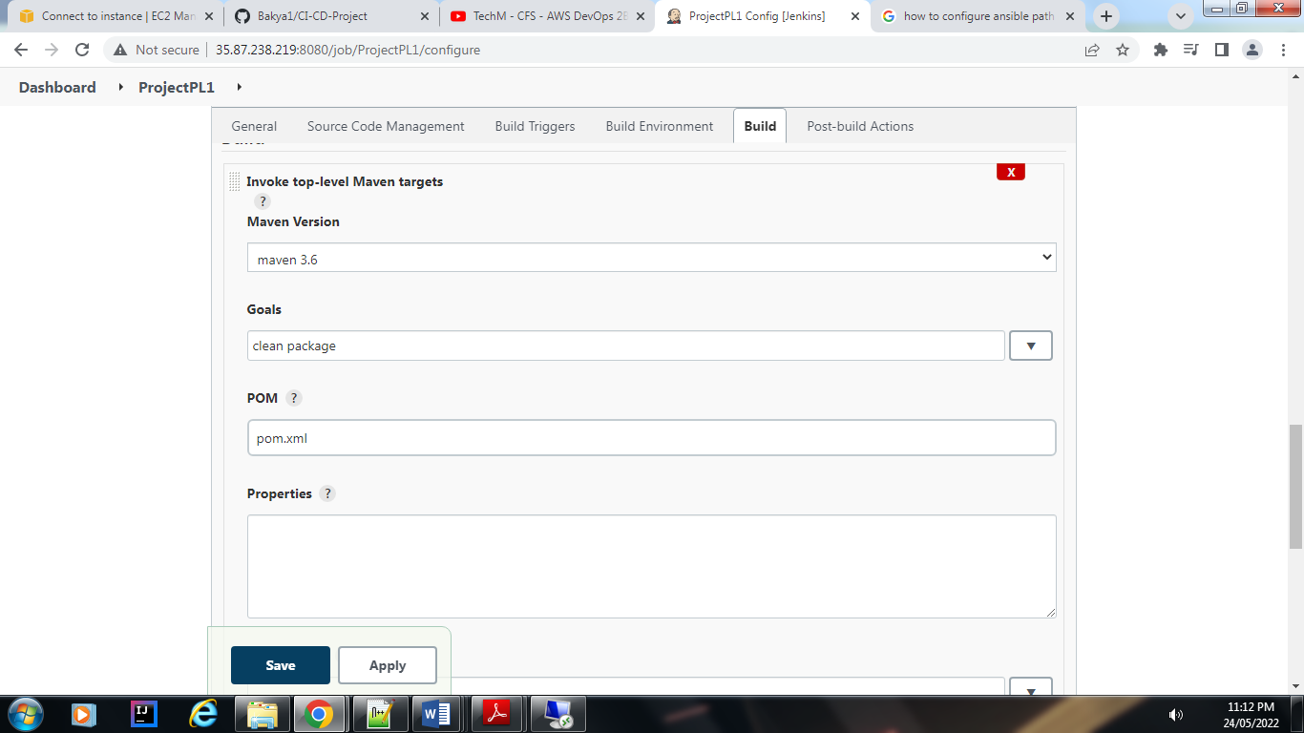

Click on save and click on build now.

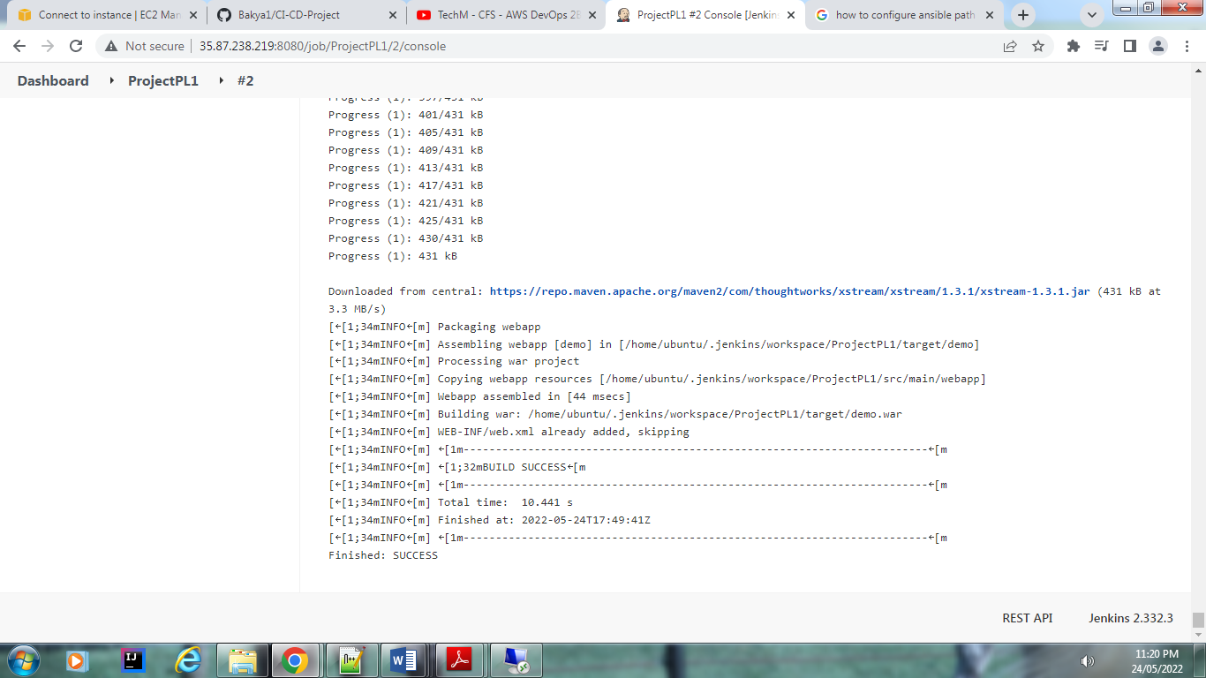

Now login to hub.docker.com and create a repo

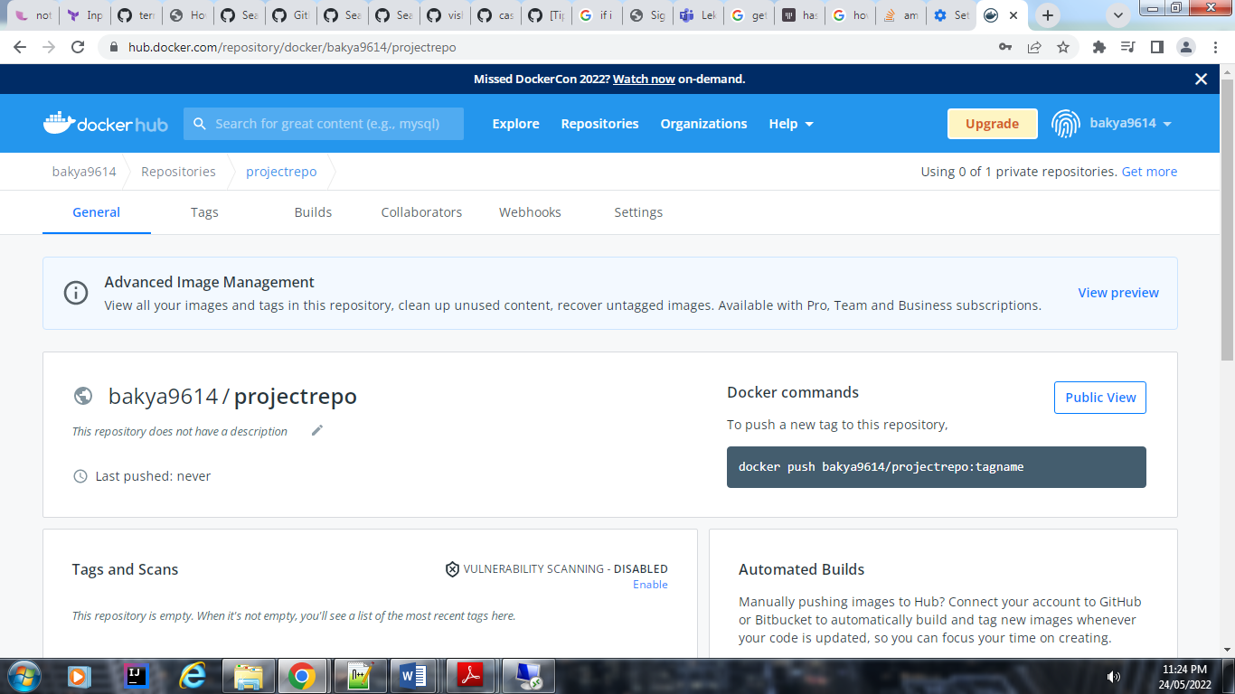

In Jenkins config 🡪 build 🡪add build step 🡪docker build and publish 🡪add repo name and select the credentials 🡪save

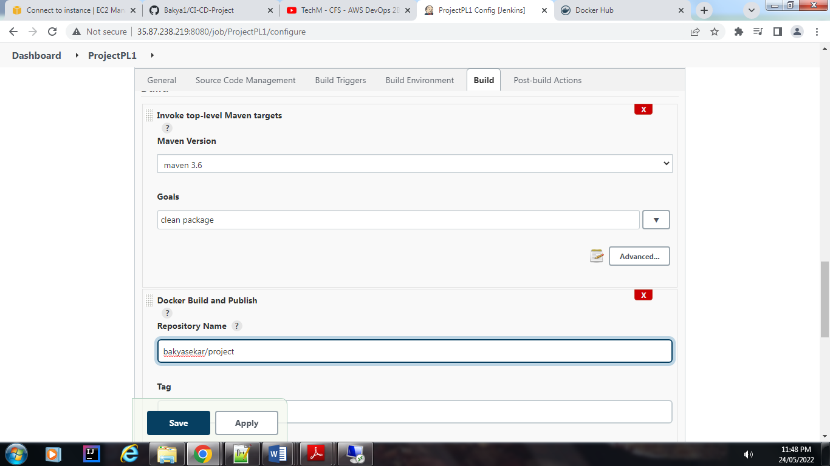

Click on build now

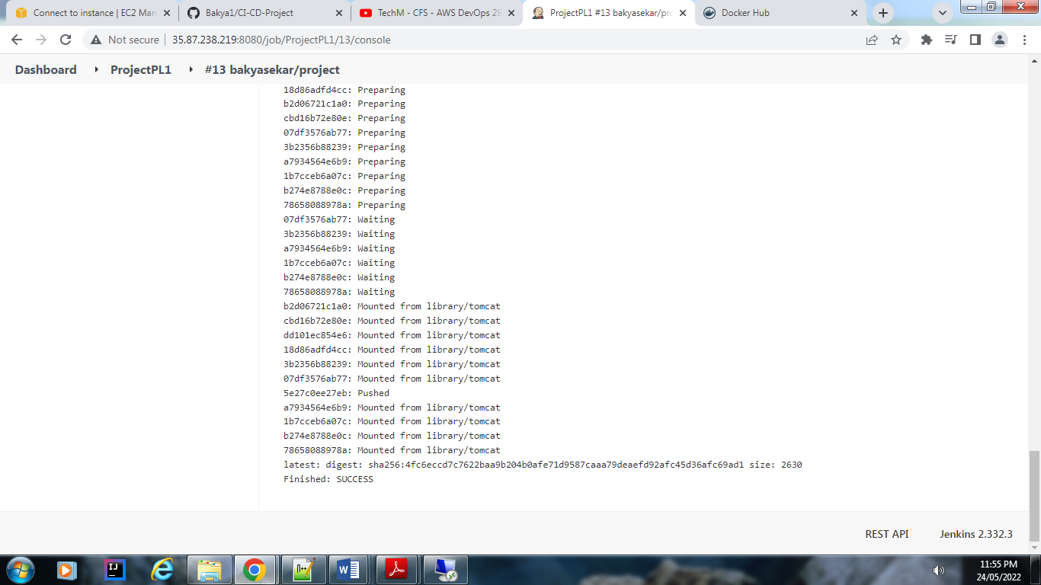

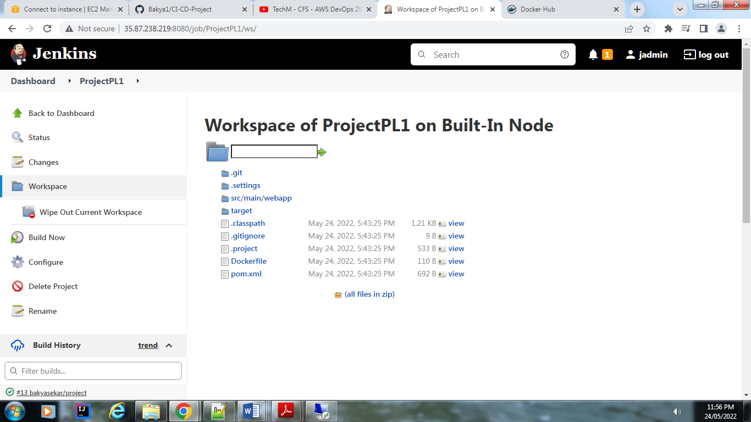

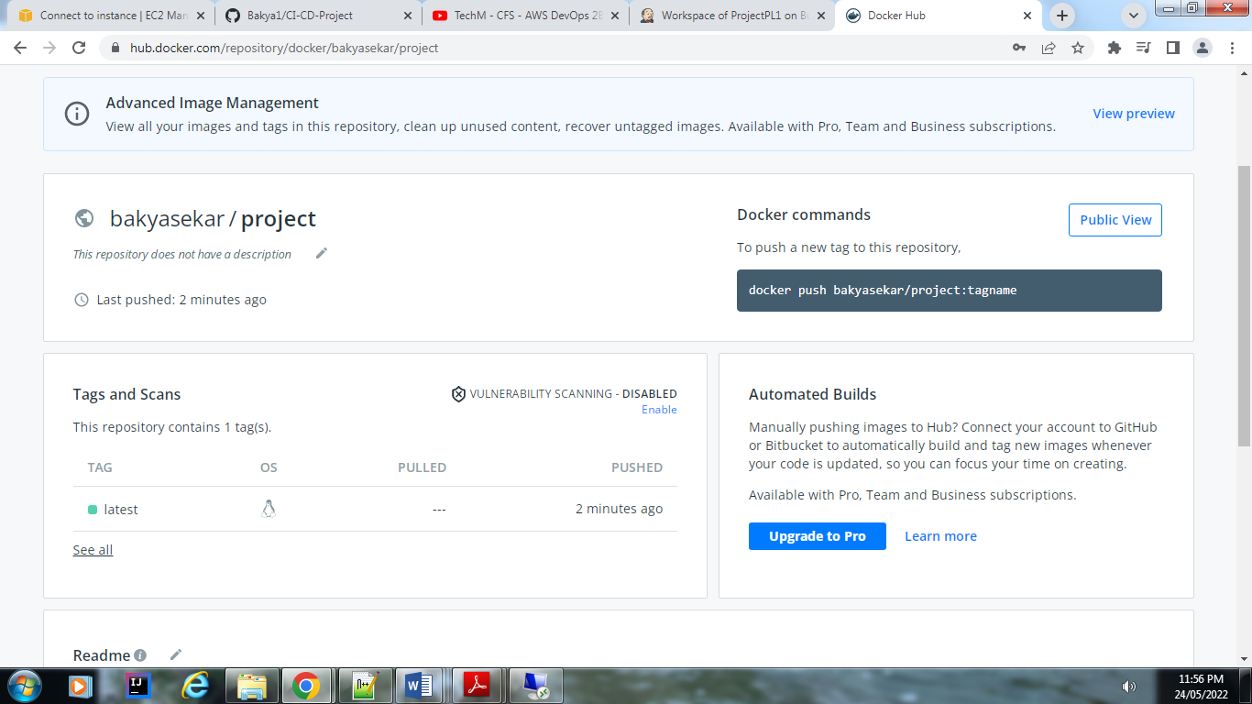

**Create EKS cluster :**

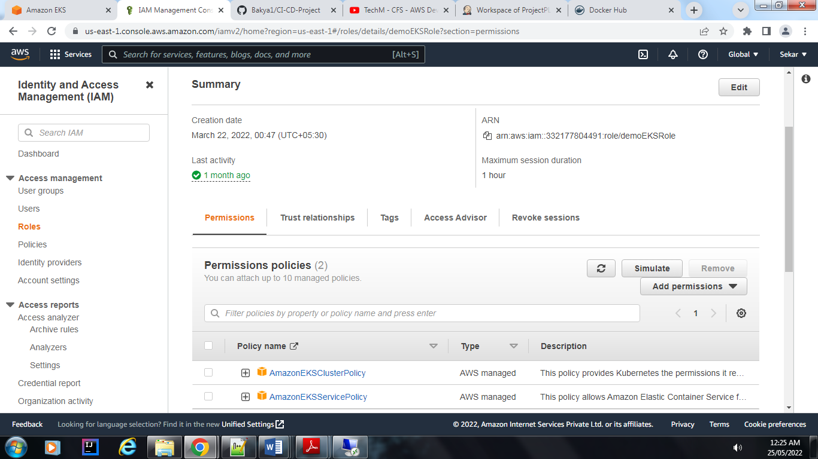

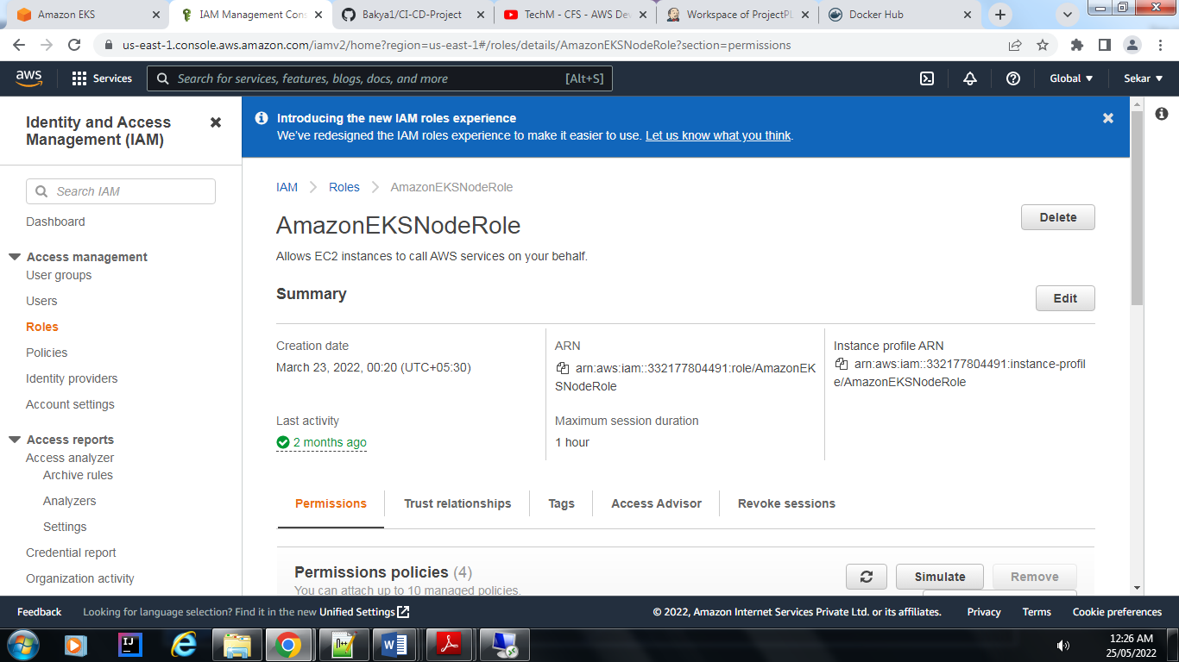

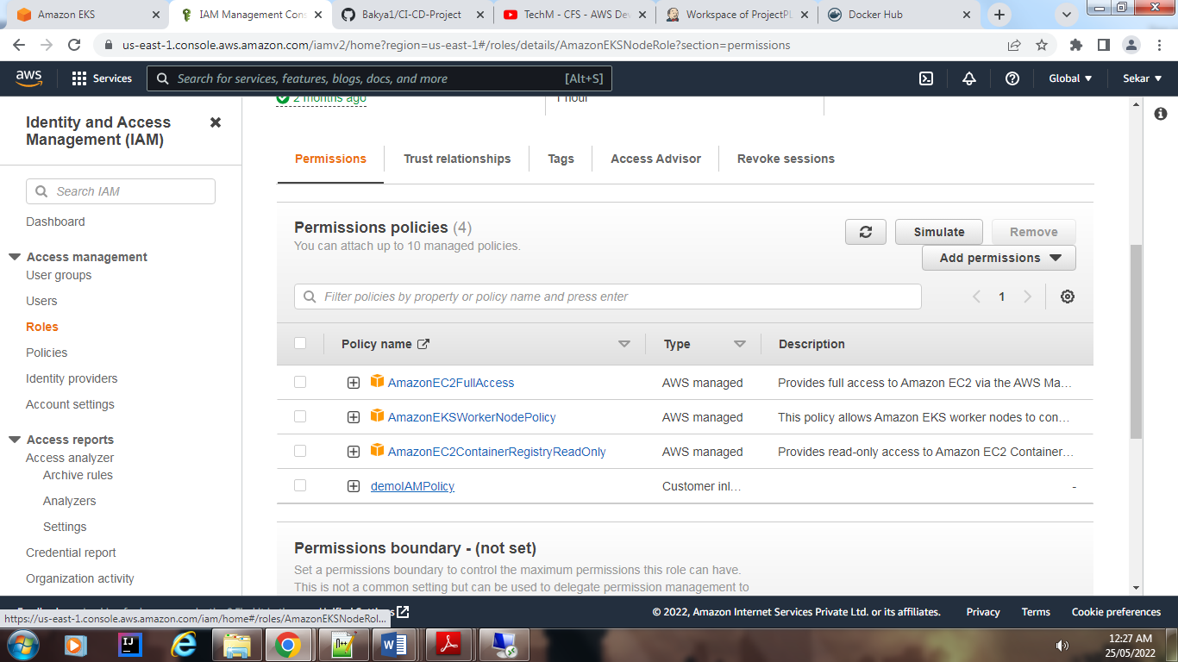

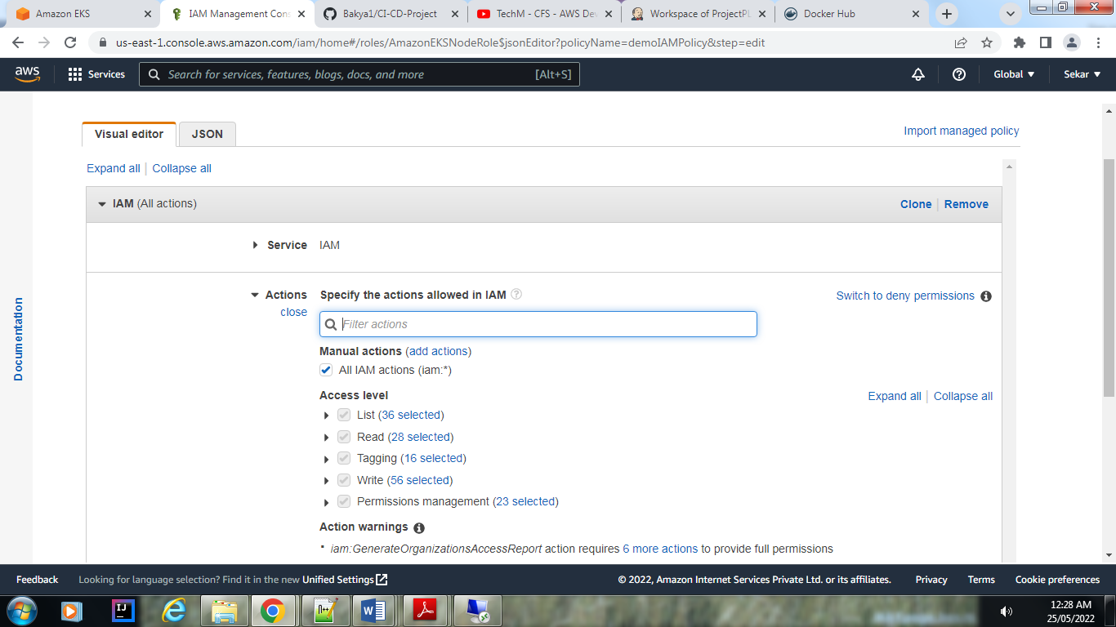

Create VPC:

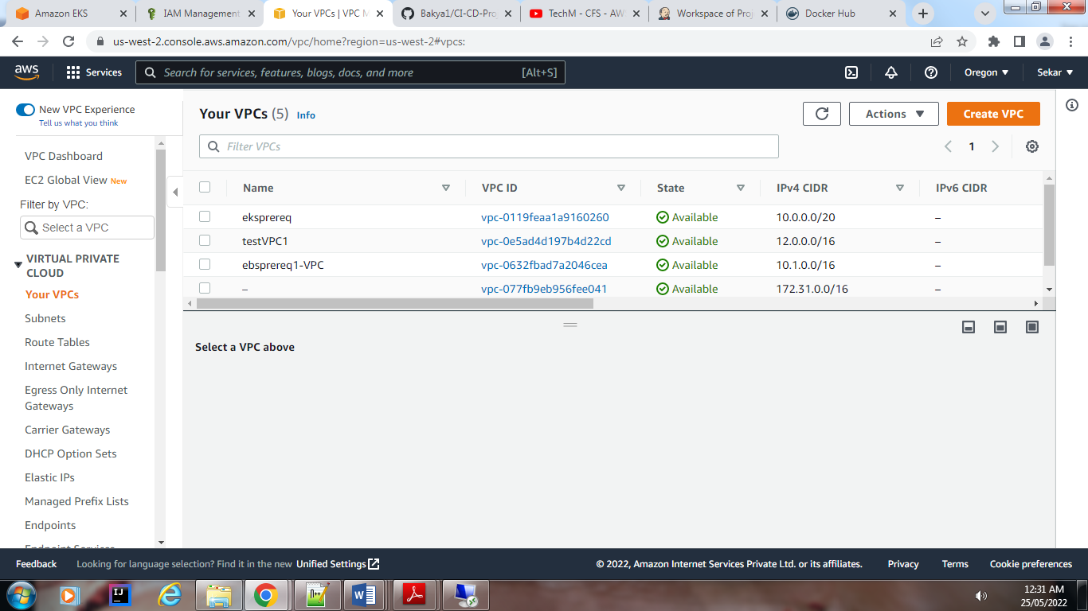

CF:

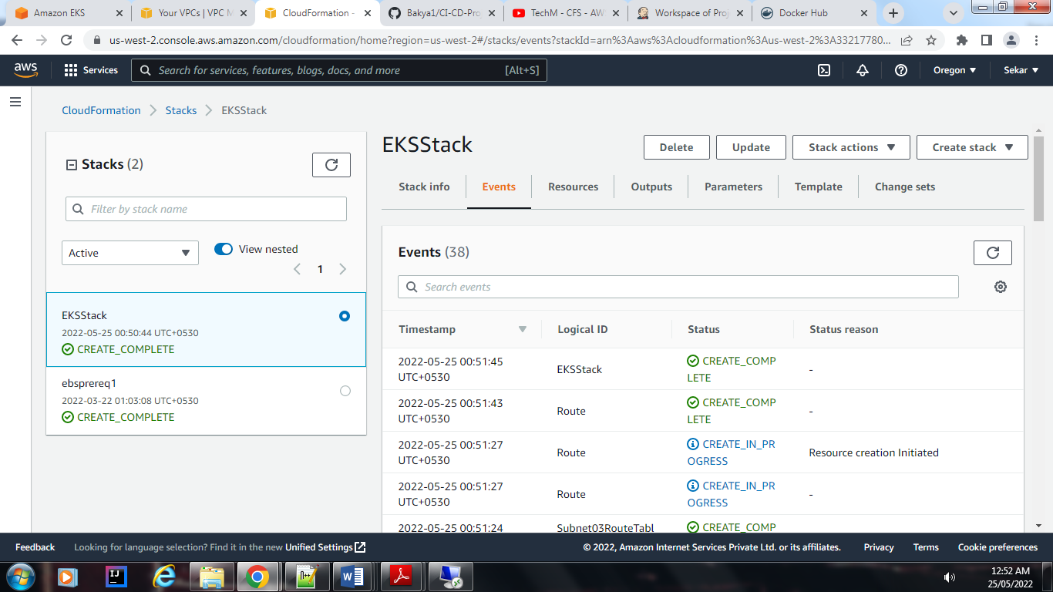

EKS cluster:

